Spring MVC notes
- Upon initialization of a DispatcherServlet, Spring MVC looks for a file named [servlet-name]-servlet.xml in the WEB-INF directory of your web application and creates the beans defined there, overriding the definitions of any beans defined with the same name in the global scope.
- Spring MVC framework designed around a DispatcherServlet, that dispatches requests to handlers, with configurable handler mappings, view resolution, locale resolution, etc
- The default handler is based on @Controller and @RequestMapping annotations.
- Special bean types in the WebApplicationContext are,
HandlerMapping --> Map incoming request to handlers and pre- and post-processor, common implementation support @Controller annotations, eg: RequestMappingHandlerMapping
automatically looks for @RequestMapping annotations on all @Controller beans

- ViewResolver --> Resolve logical String-based view name to actual View object types.
Many other are there..
- ModelAndView object encapsulate both model data and view details
- View interface has lot of implementation like Jstl View for jsp, etc to render the views.

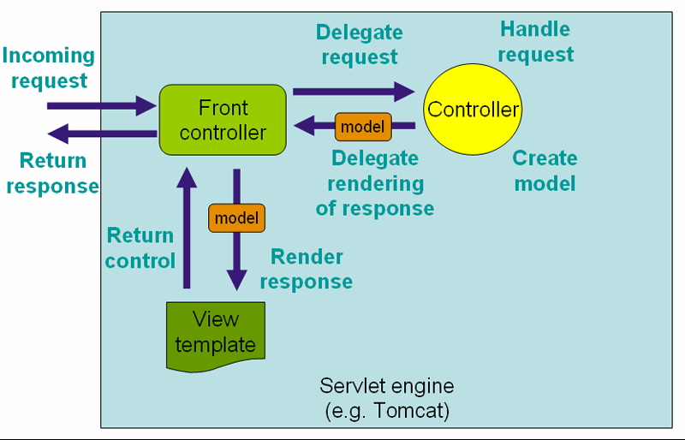

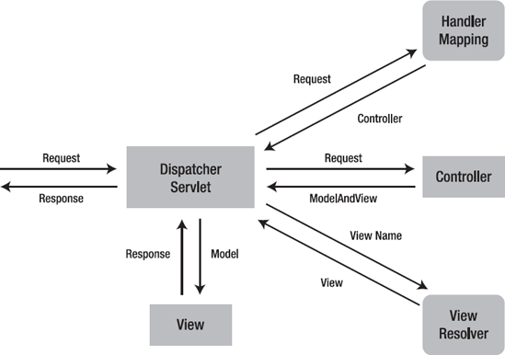

Dynamic project to Spring MVC project

Step 1 in web.xml
<!-- initializing dispatcher servlet with application context using [servlet-name]-servlet.xml-->
<servlet>
<servlet-name>springdispatcher</servlet-name>
<servlet-class>org.springframework.web.servlet.DispatcherServlet</servlet-class>
</servlet>
<servlet-mapping>
<servlet-name>springdispatcher</servlet-name>
<url-pattern>/</url-pattern>
</servlet-mapping>
<!-- -->

Step 2 create directories and move jsp and css as below,
webapp/
|-- resources/
| +-- css/
| test.css
+- WEB-INF/
+-- views/
testing.jsp

And add <mvc:resources mapping="/resources/**" location="/resources/" /> to [servlet-name]-servlet.xml

Then in .jsp file update css path like below,
<link href="${pageContext.request.contextPath}/resources/css/home.css" rel="stylesheet">
Step 3 in [servlet-name]-servlet.xml
<bean class="org.springframework.web.servlet.view.InternalResourceViewResolver">
<property name="prefix">
<value>/WEB-INF/views/</value>
</property>
<property name="suffix">
<value>.jsp</value>
</property>
</bean>

org.springframework.web.servlet.handler.BeanNameUrlHandlerMapping
org.springframework.web.servlet.handler.RequestMappingHandlerMapping --> For annaotation @Controller

<bean name="/,/cars" class="com.carworld.controller.car.CarListController" init-method="dbinit">
<constructor-arg name="dataSource" ref="dataSource"/>
<property name="carService" ref="carService"/>
</bean>
--The above snippet for landing the home page
Step 4,
Create controllers for car package by implements Controller interface and using XML bean configuration

<bean name="/cardtl" class="com.carworld.controller.car.CarDetailController" autowire="byName"/>

<bean name="/addcar" class="com.carworld.controller.car.AddCarController" autowire="byType"/>

<bean name="/delcar" class="com.carworld.controller.car.DeleteCarController" autowire="constructor"/>
Step 5,
Create DbConfiguration class using @Configuration + @Bean annotations
And modify the dao package accordingly
Step 6,
Added bean definition for service classes in [servlet-name]-servlet.xml, and modify services to use @Autowire to inject dependencies
Step 7,
Created engine and manufacturer controller using @Controller, @RequestMapping
And add below entry in [servlet-name]-servlet.xml
Step 8,
Add component scan tag for scan @Controllers other annotations in Engine and Manufacturer controller packages.
Since we are using Xml, by default XmlWebApplicationContext will be initialized, so we need to add component scan to identify the @Configuration classes. If we use AnnotationConfigWebApplicationContext, no need of ComponentScan to itentify the @Configuration classes.
<context:component-scan base-package="com.carworld.controller.engine,com.carworld.controller.manufacturer,com.carworld.dao" />
Step 9
To handle @RequestMapping annotations we need to add
<bean class="org.springframework.web.servlet.mvc.method.annotation.RequestMappingHandlerMapping"/>
<bean class="org.springframework.web.servlet.mvc.method.annotation.RequestMappingHandlerAdapter"/>

Spring MVC to Sringboot project
- Create boot project using web, jpa, mysql connector, with war or jar
- In POM.xml make sure added below dependency to render the JSP pages
<dependency>
<groupId>org.apache.tomcat.embed</groupId>
<artifactId>tomcat-embed-jasper</artifactId>
</dependency>

- Copy view to folder to src/main/webapp
- Copy css folder to src/main/resources/resource
- Copy all the pakages
- Copy dbscripts.sql to src/main/resource and rename to schema.sql
- Update jsp to correct css path
- Application.properties updates for data source, mvc, port

